For Facebook:
[Please share the event page]

Have you heard about @ConnectableJax’s Shopability Saturday coming up on April 30?
This citywide event is a celebration of inclusive businesses in Jacksonville that employ individuals with Autism, Down syndrome, and other IDD.

[insert connection to participating business, employee or IDD community].

You can search for IDD-inclusive businesses near you through an interactive map at ConnectableJax.com/Shopability. Then, make a plan to support one (or more) of these businesses either in person or online. With 150+ businesses to choose from, there really is something for everyone!

I hope you’ll join me in recognizing these forward-thinking businesses and celebrating the unique abilities of individuals with IDDs. If you plan to participate, don’t forget to download the event guide and check out the social media contest being held on the day of the event. #ShopabilityJax

For Instagram:
[Please share the below graphic]

Have you heard about @ConnectableJax’s Shopability Saturday coming up on April 30?
This citywide event is a celebration of inclusive businesses in Jacksonville that employ individuals with Autism, Down syndrome, and other IDD.

[insert connection to participating business, employee or IDD community].

You can search for IDD-inclusive businesses near you through an interactive map at ConnectableJax.com/Shopability. Then, make a plan to support one (or more) of these businesses either in person or online. With 150+ businesses to choose from, there is really something for everyone!

I hope you’ll join me in recognizing these forward-thinking businesses and celebrating the unique abilities of individuals with IDDs. If you plan to participate, don’t forget to download the event guide and check out the social media contest being held on the day of the event. #ShopabilityJax

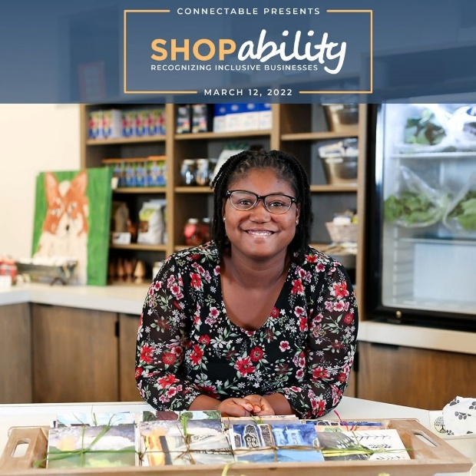

DOWNLOAD IMAGE HERE

For Twitter:
[Please Quote Tweet this tweet]

Have you heard about @ConnectableJax’s Shopability Saturday coming up on April 30?

This event is a celebration of inclusive businesses in #Jacksonville that employ individuals with Autism, Down syndrome, and other IDD.

Learn more at ConnectableJax.com/Shopability #ShopabilityJax

